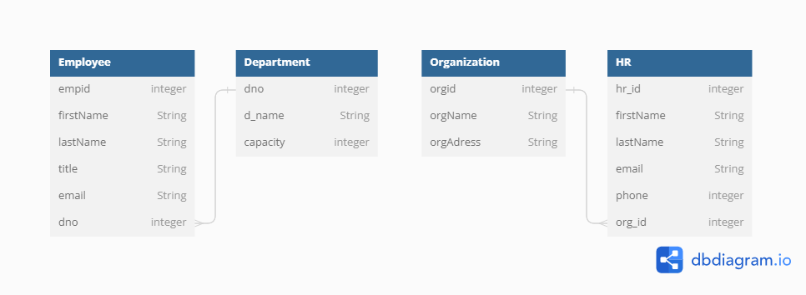

ESD PROJECT REPORT

Class Diagram

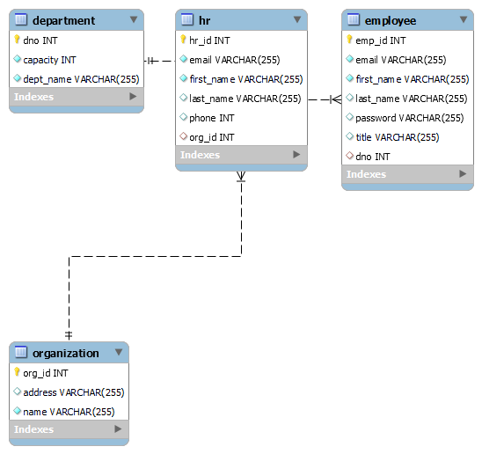

OR mapping of the class diagram